Supplementary file for “Service failure monitoring via multivariate multiple linear regression profile schemes with dimensionality reduction”

Using airline online reviews on TripAdvisor, we compared the eight proposed MMLRP-based schemes, six with dimensionality reduction (PCA-I, PCA-M, ICA-I, ICA-M, LAS-I, and LAS-M) and two without dimensionality reduction (RAW-I and RAW-M) in the case study. The letter I denotes the IC covariance and the letter M denotes the mixed covariance used in the statistic. To make a comprehensive comparison, we considered two cases with a small or large size of the test sample and further examined whether the choice of $λ$ affected the results of the case study.

1. The first case with a small sample size ($n=40$)

As shown in Figures 1-2, when setting a small size of the test sample (i.e., $n=40$), the proposed schemes with $λ=0.1$ performed as well as their counterparts with $λ=0.05$. There was one particular case for the RAW-M scheme. The RAW-M scheme with $λ=0.05$ detected the first anomaly in the 27th test sample, one test sample earlier than the RAW-M scheme with $λ=0.1$. The performance difference between them is small. Therefore, having $λ=0.05 or 0.1$ has a negligible impact in our case study.

1. The second case with a large sample size ($n=80$)

From Figures 3-4, when setting a large size of the test sample (i.e., $n=80$), the proposed schemes with $λ=0.05$ and their counterparts with $λ=0.1$ detected the first anomaly in the same sample. It indicates that having $λ=0.05 or 0.1$ has no impact in our case study.

The comparison shows that having different smoothing parameters within a small range has negligible or no impact in our case study.

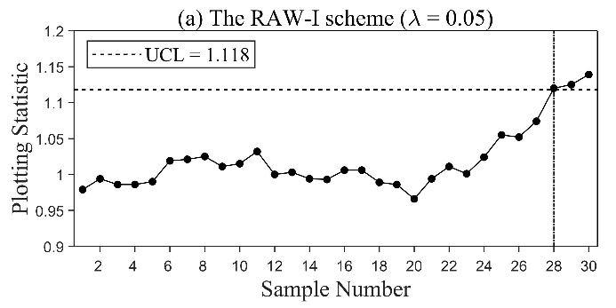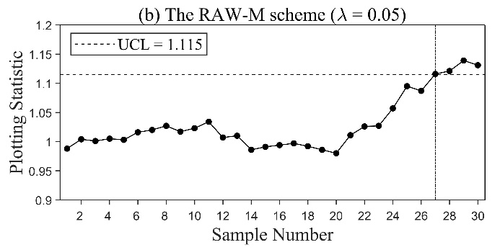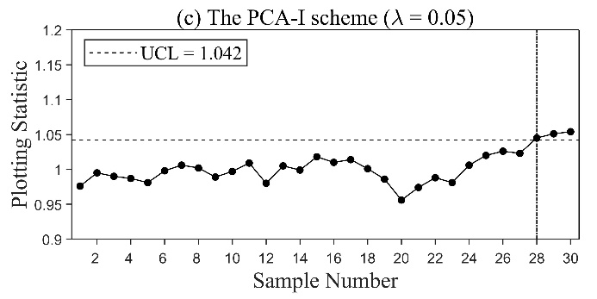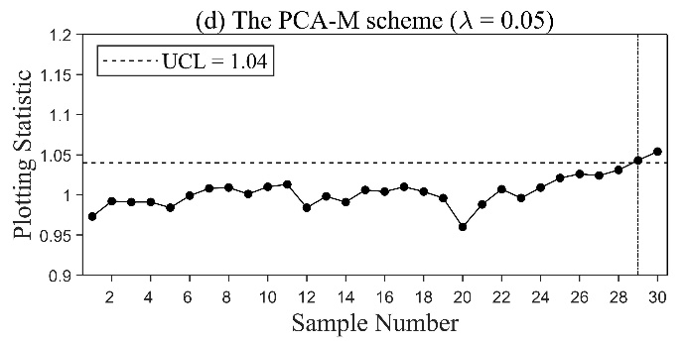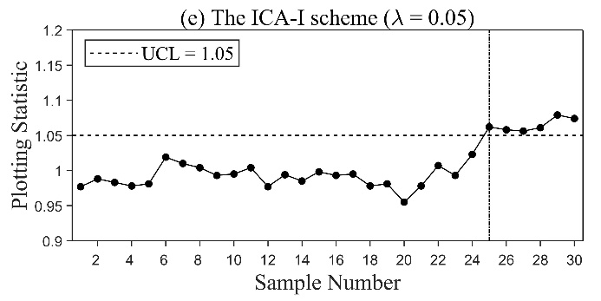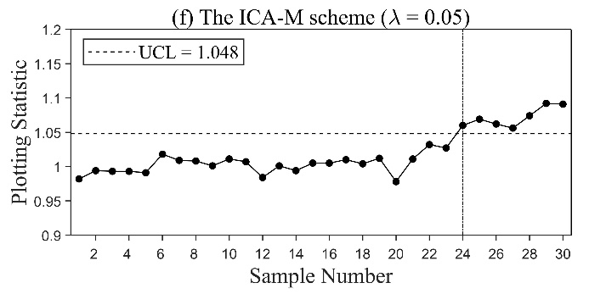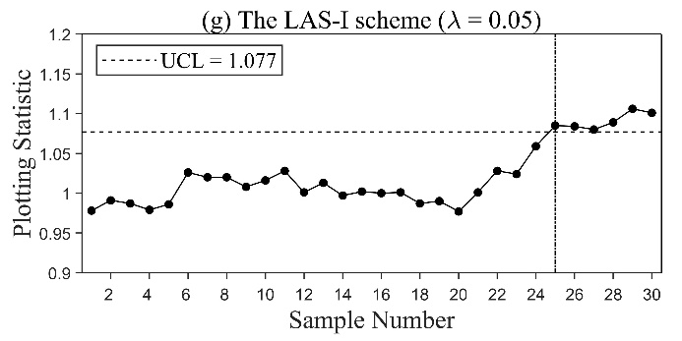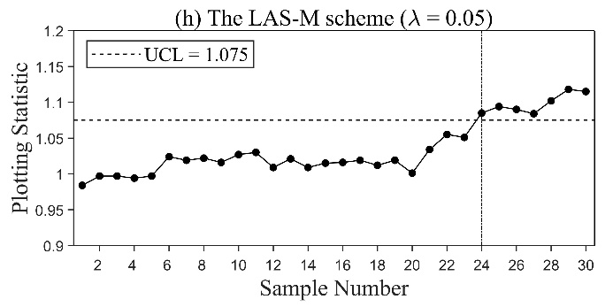

Figure 1. The first case: monitoring passenger complaints using the proposed schemes with $n=40$ and $λ=0.05$.

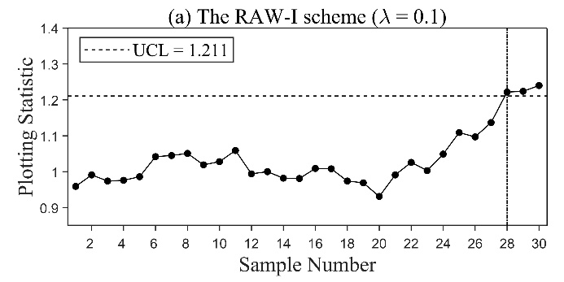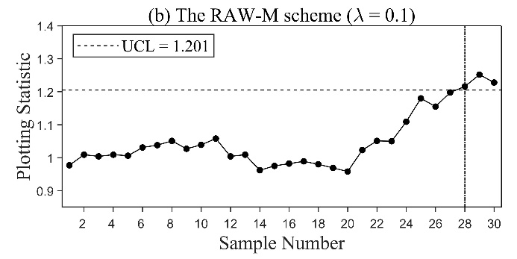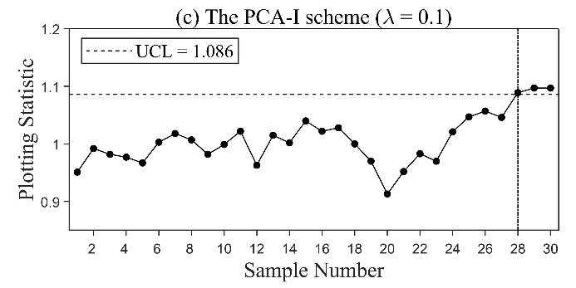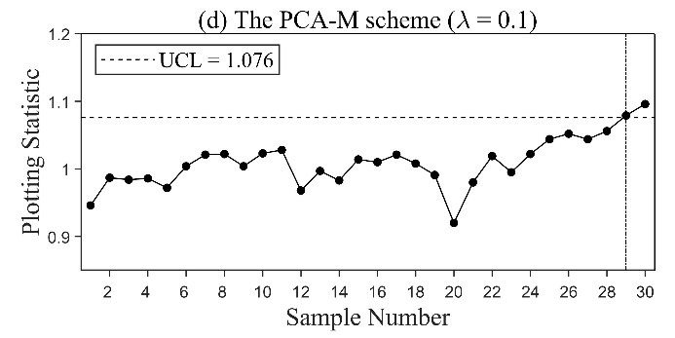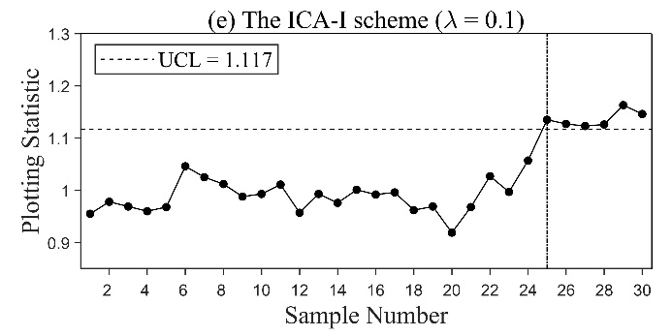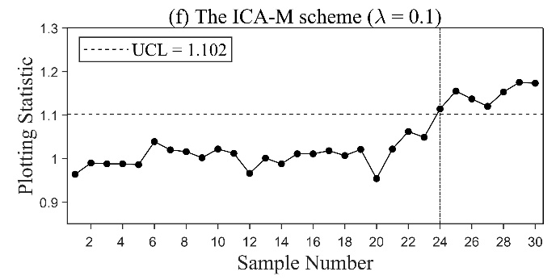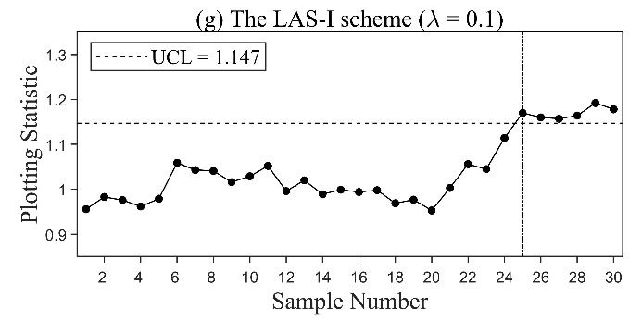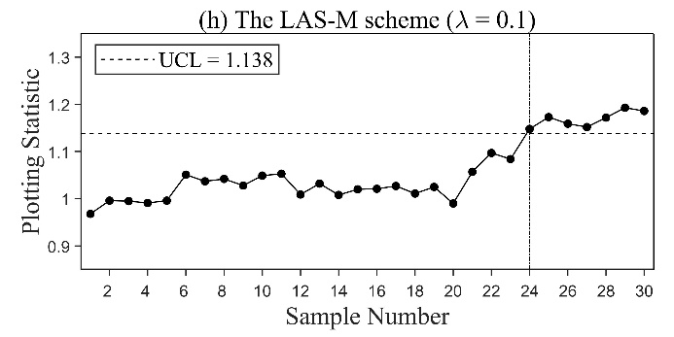

Figure 2. The first case: monitoring passenger complaints using the proposed schemes with $n=40$ and $λ=0.1$.

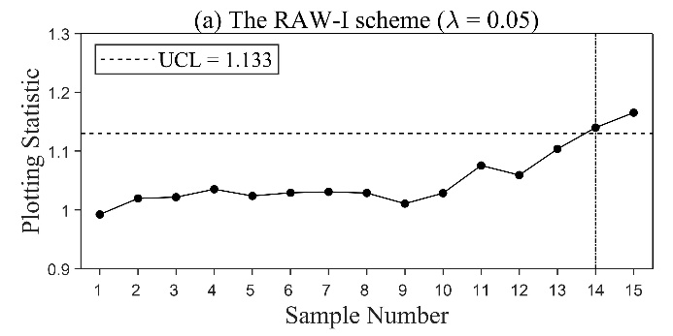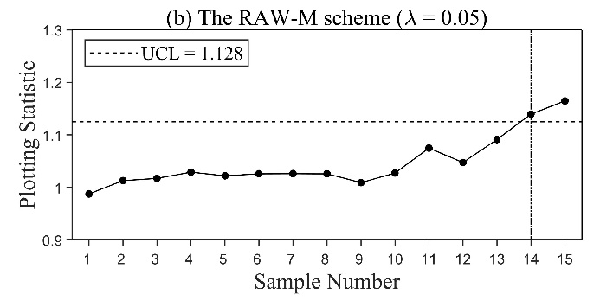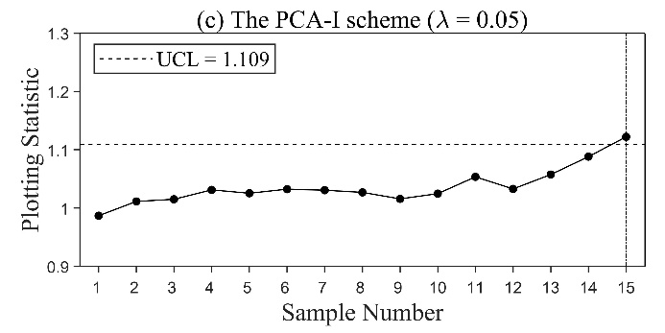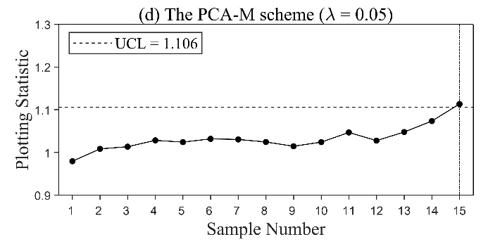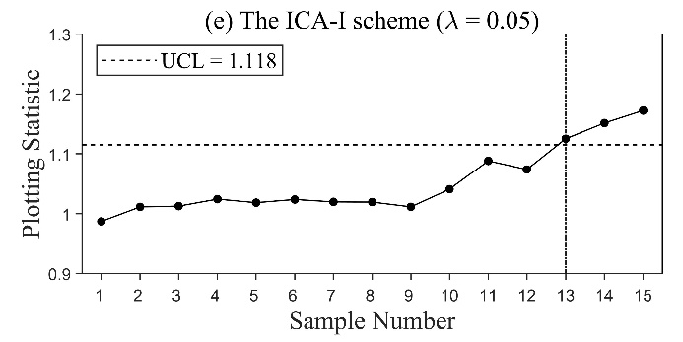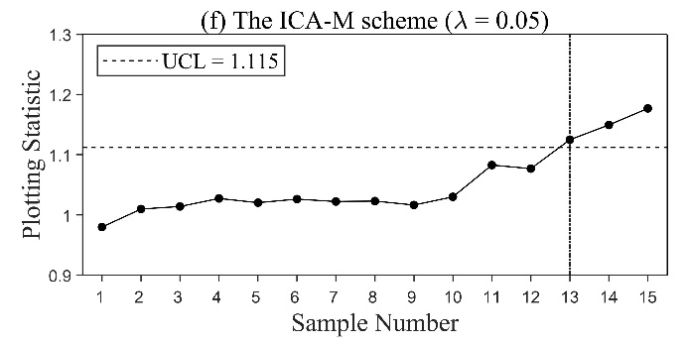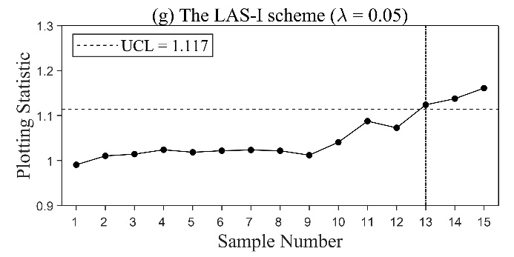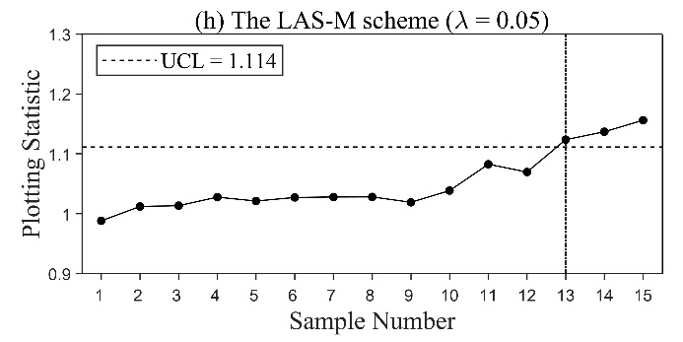

Figure 3. The second case: monitoring passenger complaints using the proposed schemes with $n=80$ and $λ=0.05$.

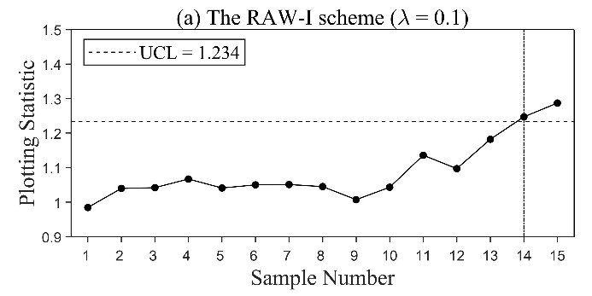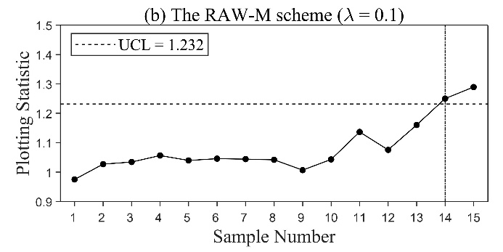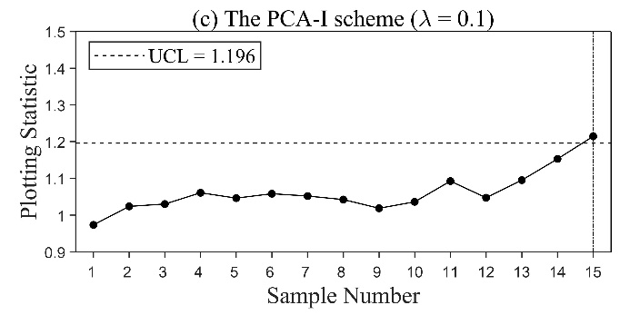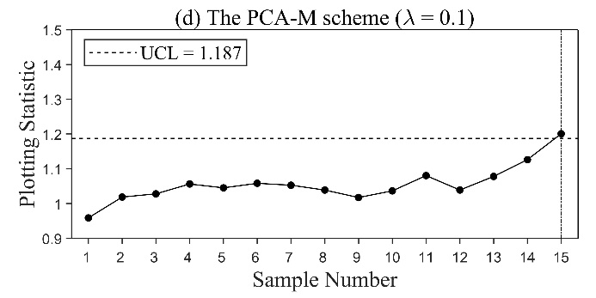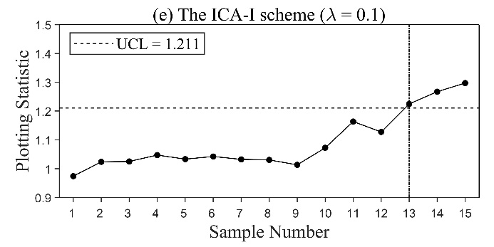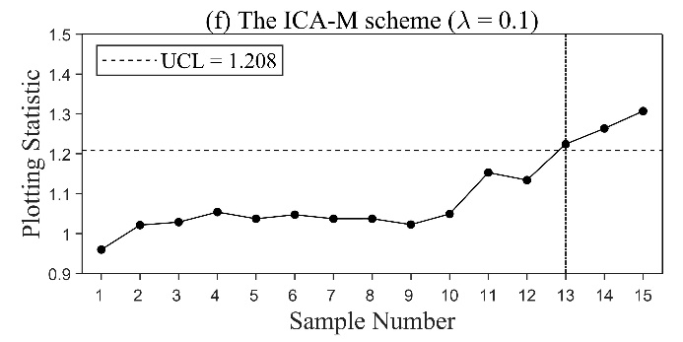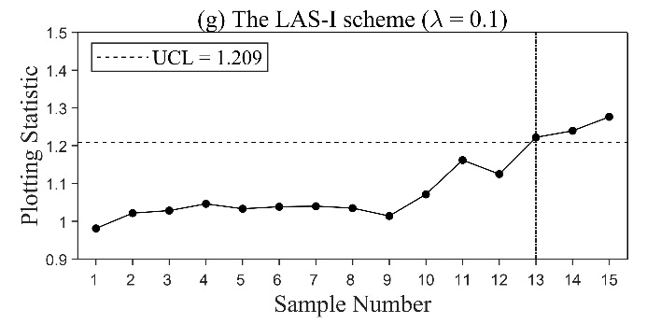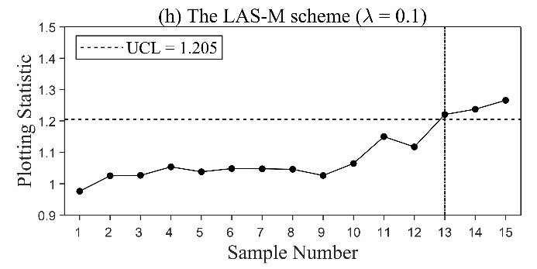

Figure 4. The second case: monitoring passenger complaints using the proposed schemes with $n=80$ and $λ=0.1$.